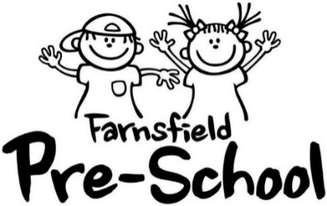

APPLICATION FOR WAITING LIST

Once you have completed this form your child will be added to our waiting list to attend Farnsfield Pre-School. Children aged from 2 years and 6 months are accepted at Pre-School.

Name of Child | Male/Female | Date of Birth
Address
 |  | Postcode
Parent/Carer Name |  | Telephone No.
Email Address

Do you attend Farnsfield Babies & Toddlers Group? Yes / No

Brothers/Sisters attending Farnsfield Pre-School sessions now or in the past? Yes / No

Is your child eligible for 2-year funding? (a letter/email received from the County Council?) Yes / No

Are/will you be claiming extra (16 - 30 hours) extended funding? Yes / No

Do you claim funding elsewhere?.........................................................................................................

Which School is your child likely to attend? .........................................................................................

How did you first learn of Farnsfield Pre-School? ................................................................................

When would you like your child to start at Pre-School?.........................................................................

Are you or your partner considered to be a key worker? ………………………………………………….

If yes, occupation: …………………………………………………………………………………………...…

Sessions offered are: Mon-Fri (term-time) 9.00am – 12 noon and/or 12.00 noon - 3.00pm

We will contact you approx. 4 weeks prior to your child turning 2 ½ to agree a start date and preferred sessions, unless you wish to start at an alternative time. 15 hours free funding is available to all children from the start of the term after their 3rd birthday. We do our best to accommodate people who are eligible for the extended entitlement (30 hours) funding, but places are limited. Invoices will be issued half termly for all other sessions.

Signed .......................................................... (Parent/Carer) Date ..........................................................

By completing and submitting this form, you consent to us holding this data securely. Once your child leaves Pre-School this form will be destroyed. If you require a copy of our Data Policy, please let us know.

